**Step 1**

**🡪 At first we open a new folder** (Project 🡪 web portfolio) in our laptop (I opened in F drive 🡪 Projects (F) 🡪Web development 🡪 web-portfolio)

We make a website just like this. For this site related resource we can get it from GIThub website 🡪 then 🡪 <https://github.com/ProgrammingHero1/complete-web-development-bangla-resources>

Now 🡪 **we will download this file or will do CLONE.**

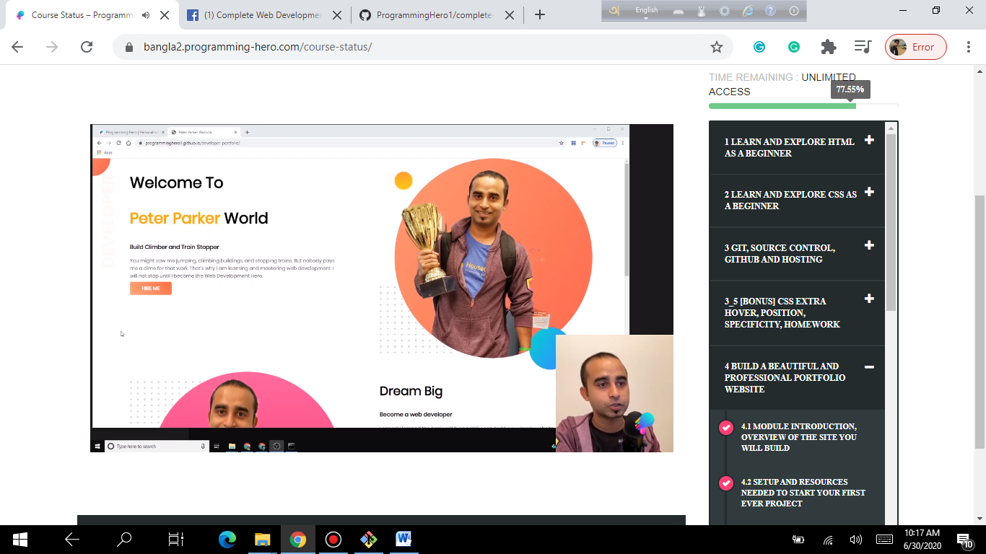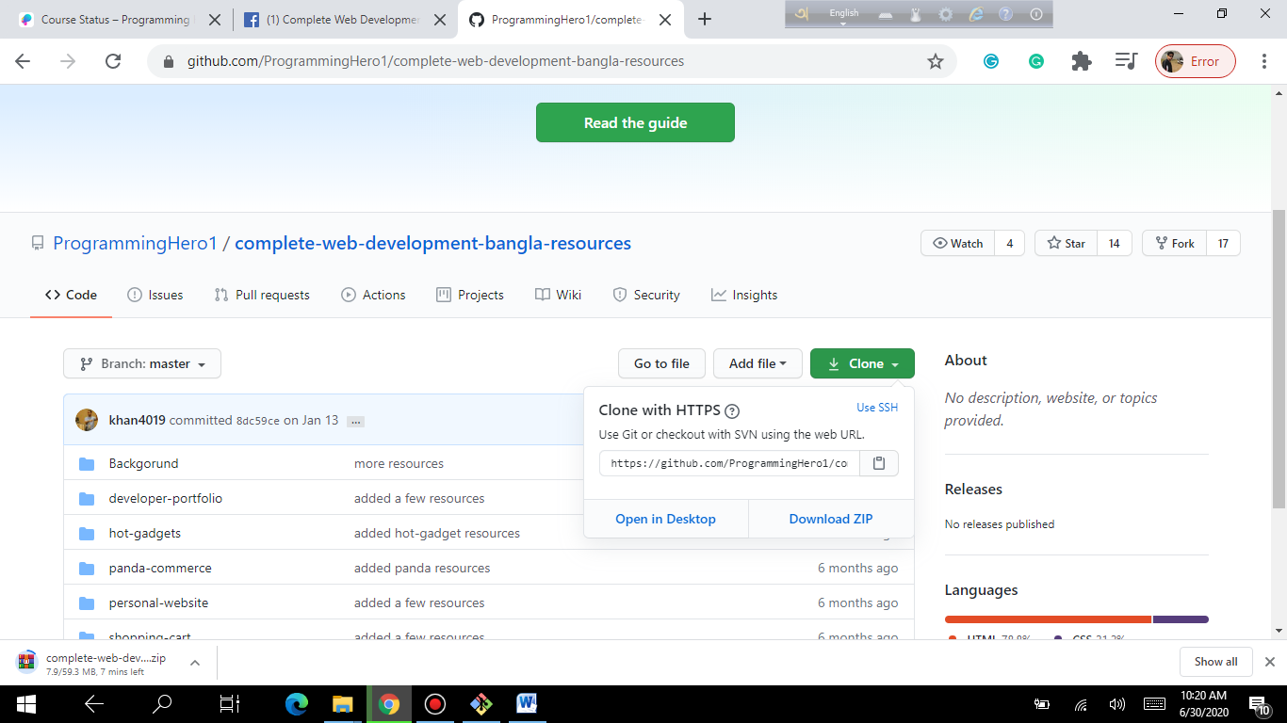

**For do CLONE** 🡪 go copy URL 🡪 click copy tag 🡪

Now we open a command line 🡪 go 🡪 start menu 🡪 write CMD 🡪 Command prompt 🡪 git Clone right click (before right click copy URL link from clone from programming website at Github)

No.1: After right click we will see below screen (that’s mean file downloading) in photo 1

No.2: After right click if it shows fatal command then we write one more line as per photo no 2 then it will start downloading.

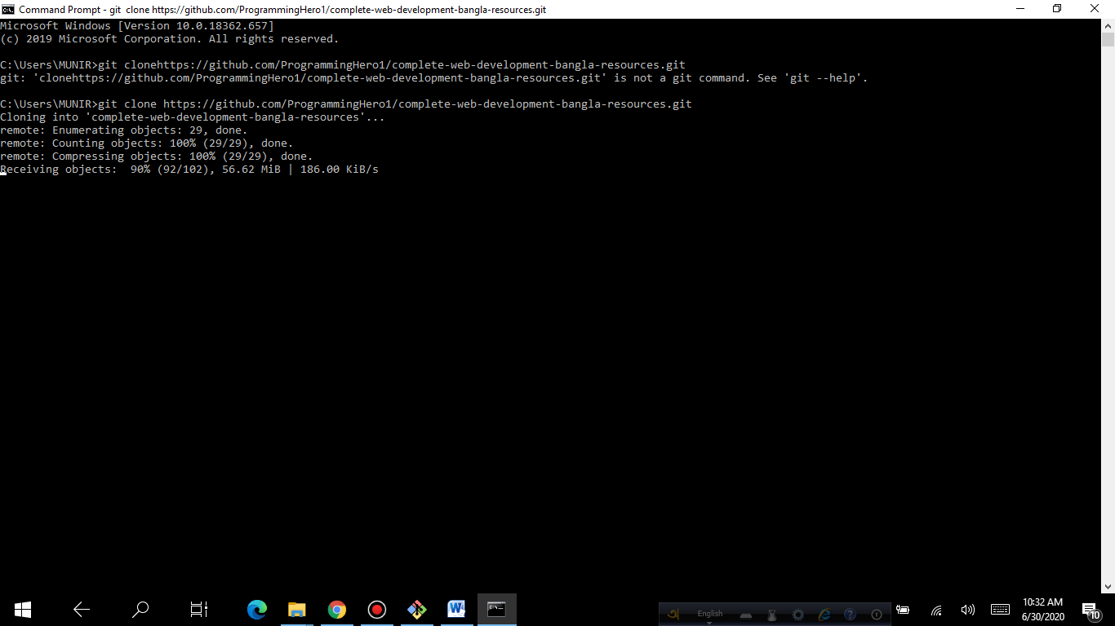 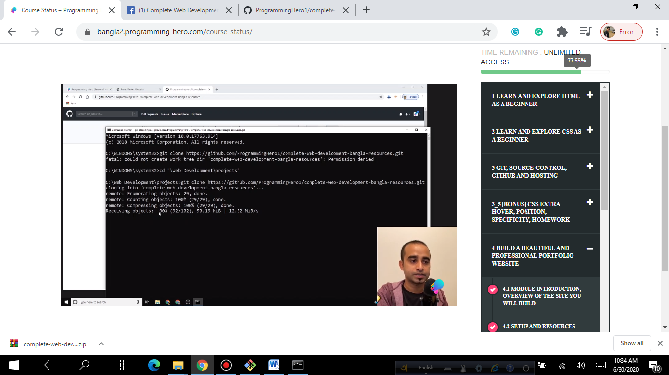

*After 100% download complete then we can copy this file from C drive 🡪 users 🡪 MUNIR 🡪 complete---webdev….file 🡪 Now we can cut/copy and paste it to our project drive/folder file.*

**Now we open this clone file (complete web development…..) 🡪 open developer portfolio 🡪 copy these images 🡪 paste to web portfolio 🡪 images folder**.

**Step 2:**

*when we start to build any website at first we will do connect it with my GIThub profile in order to do CLONE or SUBMIT.*

*Now 🡪 open my GIThub Profile main page🡪 Click 🡪 + sign on top 🡪 create new repository 🡪 repository name (better to use same name which one you write in your laptop) 🡪 web-portfolio 🡪 create repository*

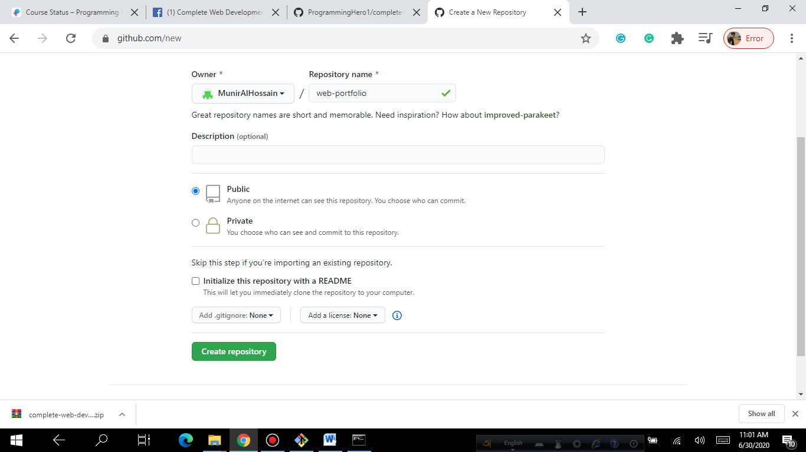

***Step 3:***

***Now open 🡪 Visual Studio Code from our system 🡪 open folder 🡪 Projects (F)🡪 Web Development🡪 web-portfolio 🡪 select folder🡪 enter***

*We did it to open this web-portfolio folder in visual studio code to open all file/folder which is inside web portfolio folder. ~~Now we do connection this with GIThub~~*

***STEP 4:***

***Now go Visual Studio Code 🡪 View 🡪 terminal 🡪 now we can see below screen where our web-portfolio is showing inside terminal.***

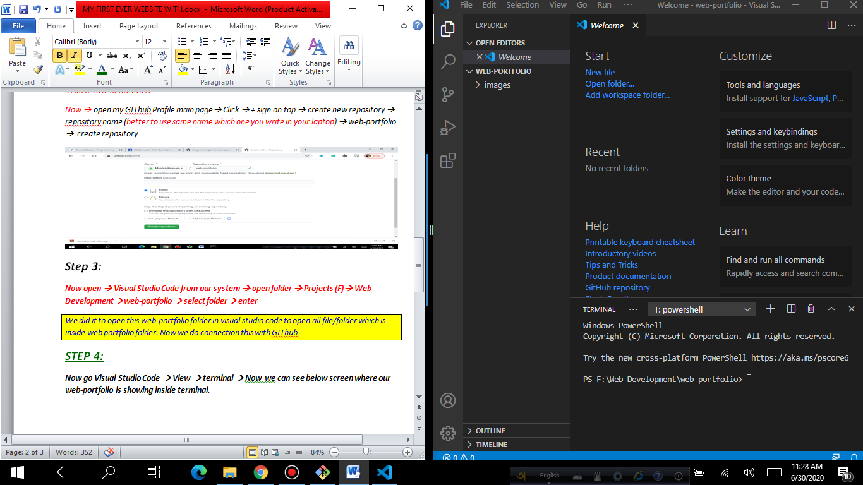

***Step 5:***

***Now,***

*🡪 Open your repository file on your Github*

*🡪 Copy line by line and enter command in terminal box to match with we web-portfolio (website) to repository.*

***Process 1****: echo 🡪 (copy and paste from repository file)*

***Process 2:*** *git init 🡪 (to initialize copy and paste from repository file)*

***Process 3:*** *git add . 🡪 (To applied this formula to make ready to add all files from our web- portfolio)*

***Process 4:*** *git commit -m"exciting web portfolio"🡪 (to commit our project and add all files)*

***Process 5:*** *git remote add origin*

***Process 6:*** *git push –u origin master*

*🡪 6a. (After applied this formula then full system will push automatically )*

*🡪6b. If required user name and password to login Github, then 🡪 When login done successfully then our all projects/ full system will push automatically)*

**Windows PowerShell**

Copyright (C) Microsoft Corporation. All rights reserved.

Try the new cross-platform PowerShell https://aka.ms/pscore6

**PS F:\Web Development\web-portfolio> echo "# web-portfolio" >> README.md**

**PS F:\Web Development\web-portfolio> git init**

Initialized empty Git repository in F:/Web Development/web-portfolio/.git/

**PS F:\Web Development\web-portfolio> git add .**

**PS F:\Web Development\web-portfolio> git commit -m"exciting web portfolio"**

[master (root-commit) 65aae34] exciting web portfolio

8 files changed, 0 insertions(+), 0 deletions(-)

create mode 100644 README.md

create mode 100644 images/dream-bg.png

create mode 100644 images/exp-bg.png

create mode 100644 images/jhankar.png

create mode 100644 images/jhankar2.png

create mode 100644 images/my-bg.png

create mode 100644 images/my-bg2.png

create mode 100644 images/top-banner.png

**PS F:\Web Development\web-portfolio> git remote add origin** https://github.com/MunirAlHossain/web-portfolio.git

**PS F:\Web Development\web-portfolio> git push -u origin master**

Enumerating objects: 11, done.

Counting objects: 100% (11/11), done.

Delta compression using up to 4 threads

Compressing objects: 100% (10/10), done.

Writing objects: 100% (11/11), 1.34 MiB | 540.00 KiB/s, done.

Total 11 (delta 0), reused 0 (delta 0), pack-reused 0

To https://github.com/MunirAlHossain/web-portfolio.git

* [new branch] master -> master

Branch 'master' set up to track remote branch 'master' from 'origin'.

**PS F:\Web Development\web-portfolio>**

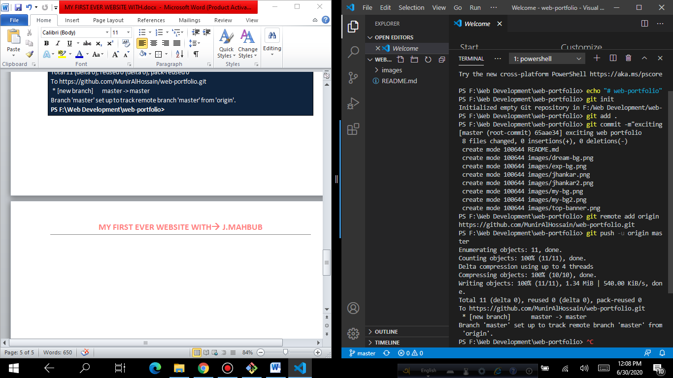

**STEP 6:**

* Now at first open a new file in your visual studio code and give name 🡪 index.html
* OR we can open a file to use this steps 🡪 ctrl N 🡪 untitled -1 🡪 edit name & save as 🡪 to web-portfolio folder.

After creating index.html file **🡪 ! 🡪 Enter (we do it for html default code creation)**

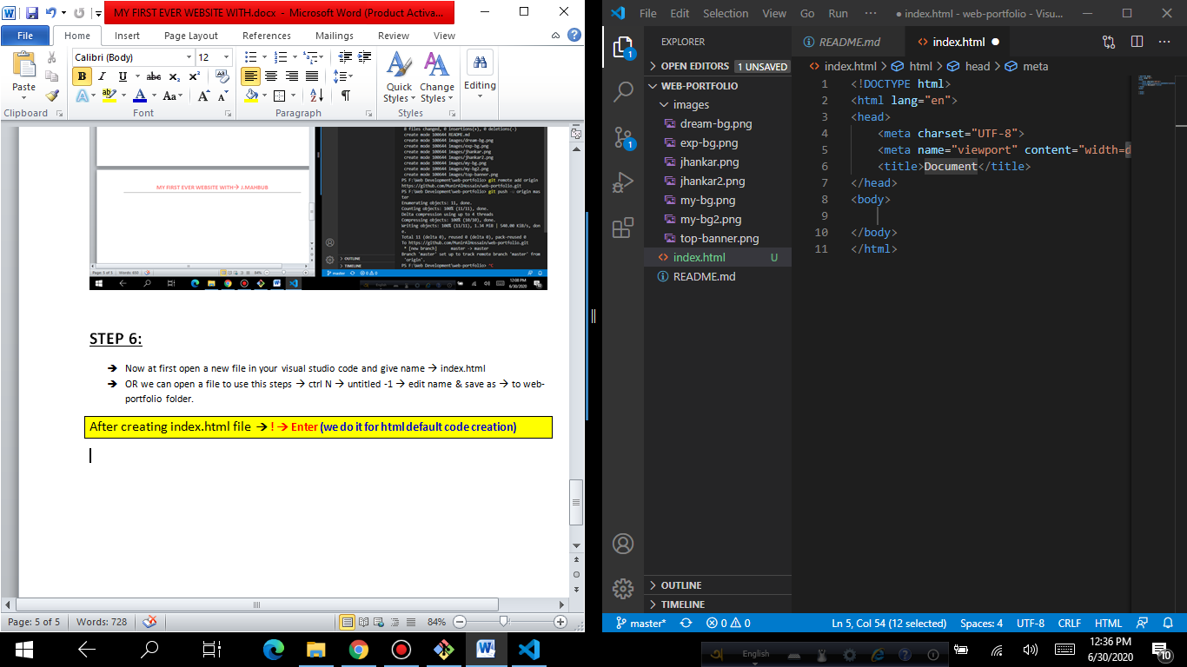

**Give your website title 🡪 (Munir Web Developer)**

* **Now create a style.css file. And connect with index.html file**
* **Otherwise it will not connect each other.**

**To write link:css then it will show this automatically🡪** <link rel="stylesheet" href="style.css">

**Step 7:**

**Process1: write these h1 headings and save.**

<body>

    <h1>Welcome To</h1>

    <h1>My First Website</h1>

</body>

**Process 2: go 🡪 style.css 🡪**

h1{

  font-size: 50px;

}

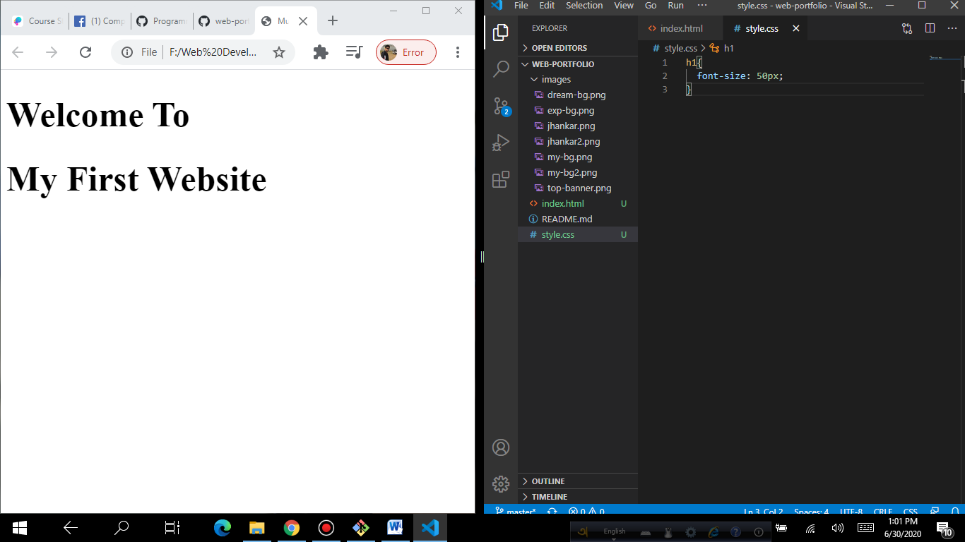

**To use any specific font we use this formula. Go Google font 🡪 select Popins font 🡪 then copy html link and paste it to html.index file just below our title tags.**

<link href="https://fonts.googleapis.com/css2?family=**Poppins:wght@300**&display=swap" rel="stylesheet">

**And in style.CSS file: first we write body tag (because we will use this font for this full website all fonts.)**

body{

    font-family: 'Poppins', sans-serif;

}

**Now we can see our font style is changed.**

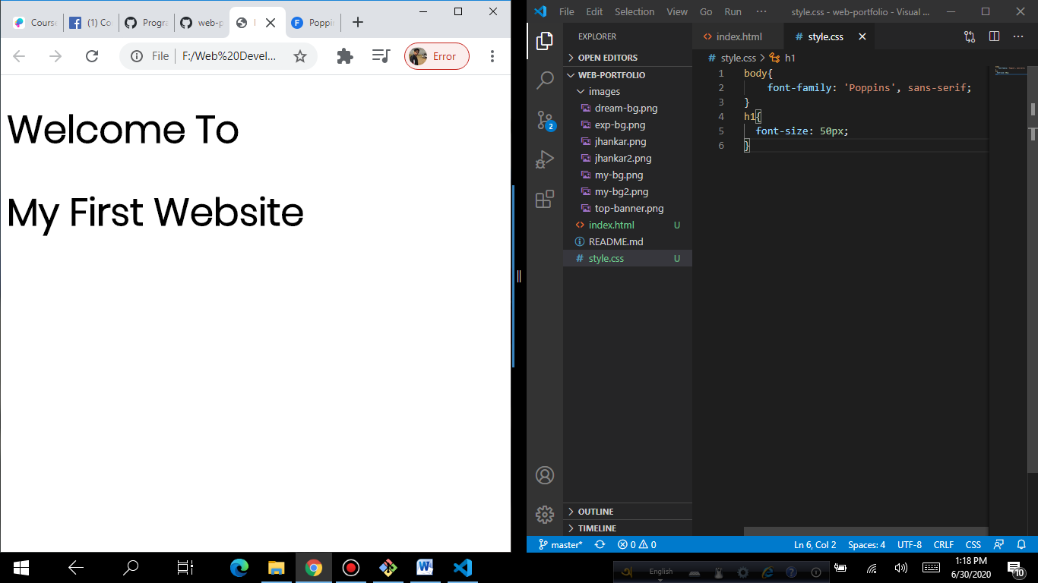

**Now we give a different color for our My First words.**

**So, we will use span tags in html file🡪**

<h1><span class="first-site">My First</span> Website</h1>

**IN CSS 🡪**

.first-site{

   color: blue;

}

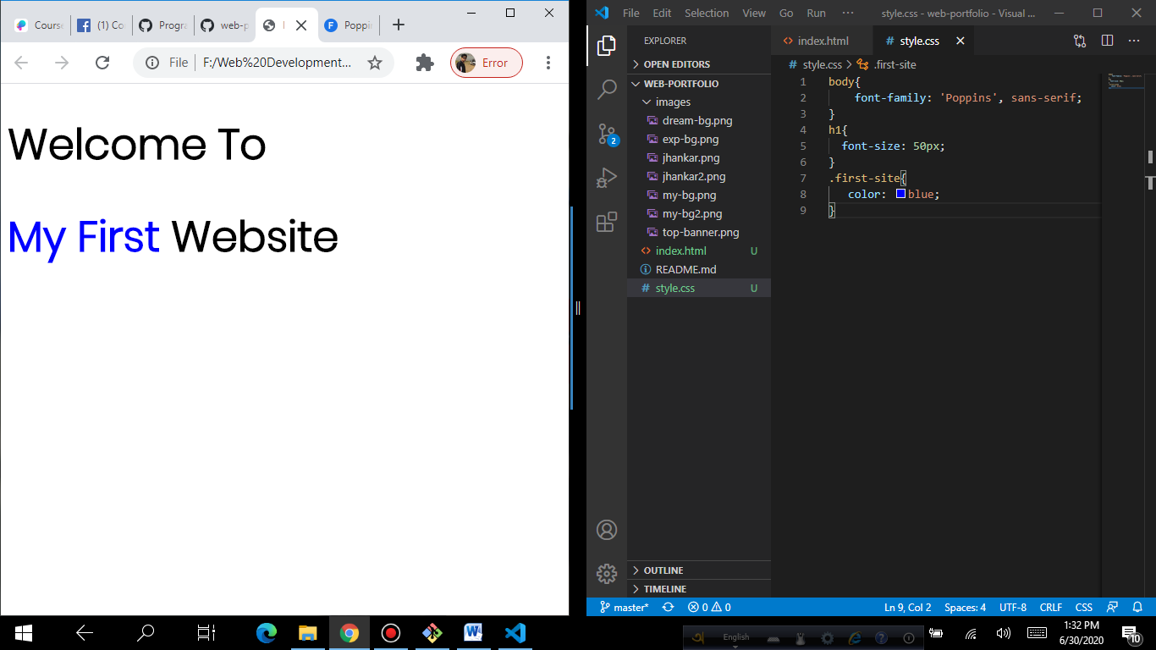

***MY PARAGRAPH FILE: (to see all in a paragraph line system we go 🡪 VS Code 🡪 View 🡪 Toggle Word Wrap 🡪 Click)***

<p>I am very much interested to be an expert Web Developer. I am an experienced professional in the Telecommunication sector. Worked with national and multinational companies for various roles in local and abroad. Due to the current COVID -19 pandemic situation, I realized that the future world is going to face an economic crisis and that will impact in all sectors. More employees will cut from almost every company. And job competition will be so hard or more competitive for a desired position. Most of the employer will hire resources form an online platform for their purpose serve immediately. So, I take this project very seriously for my future goal.</p>

**VIDEO 4.4:**

**STEP 8:**

* **Now go/ download a website for remove back-ground from image.**

[Remove Background from Images | InPixio Photo Cutout Tool](http://Remove Background from Images | InPixio Photo Cutout Toolwww.inpixio.com )

<https://www.inpixio.com/remove-background/>

* And download this website for edit photo/

[Photopea | Online Photo Editor](http://Photopea | Online Photo Editorwww.photopea.com)

[www.photopea.com](http://Photopea | Online Photo Editorwww.photopea.com)

**step1 1:**

Go to 🡪 <https://www.inpixio.com/remove-background/> 🡪 Choose a photo from your laptop 🡪 then select area that w you want to remove 🡪 Save your photo.

Step2:

Go to 🡪 [www.photopea.com](http://www.photopea.com) 🡪 Open photopea 🡪 Select a background color from your laptop 🡪 then drag it to photopea.--> Now drag here your edited photo. 🡪 select ellipse (here you can see rectangular which you need to change) 🡪 go select 🡪 inverse 🡪 delete 🡪 will show alert 🡪 put your cursor on top (your photo) 🡪 right click 🡪 resterize 🡪 Delete 🡪 Enter

[ Now we can use move tool if we need to little move our photo.]

After edit done ww will save it 🡪

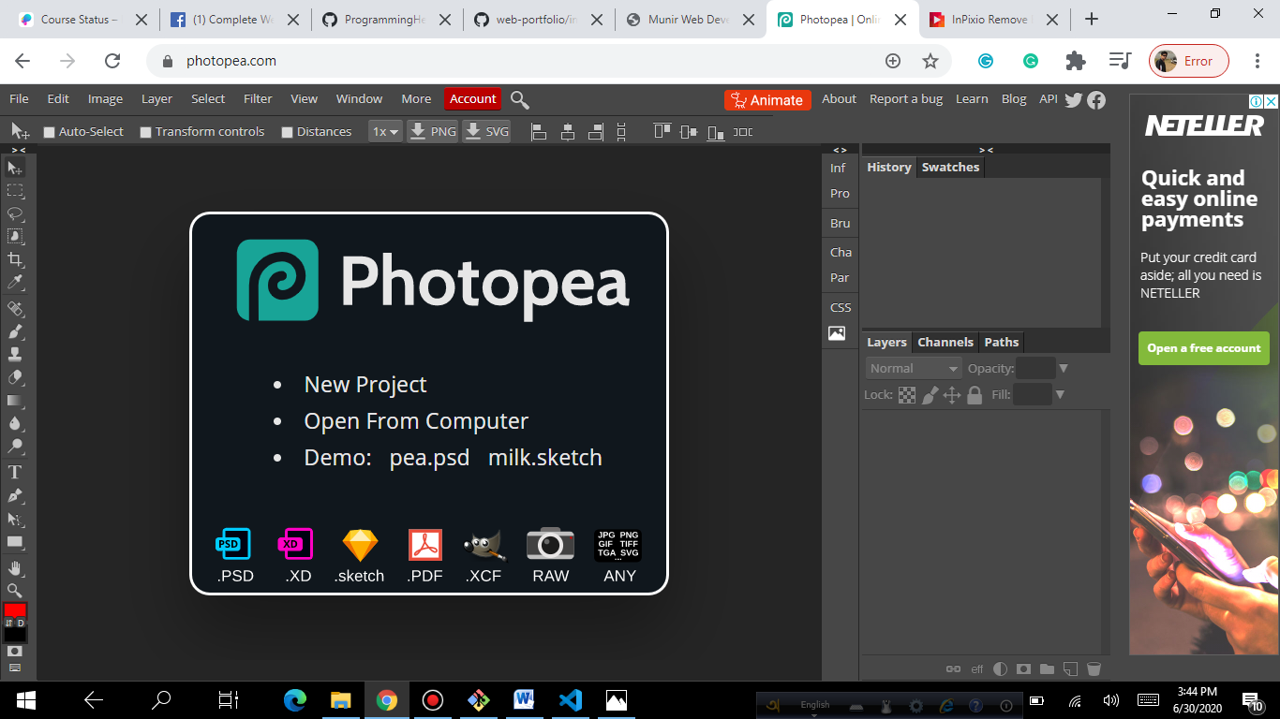

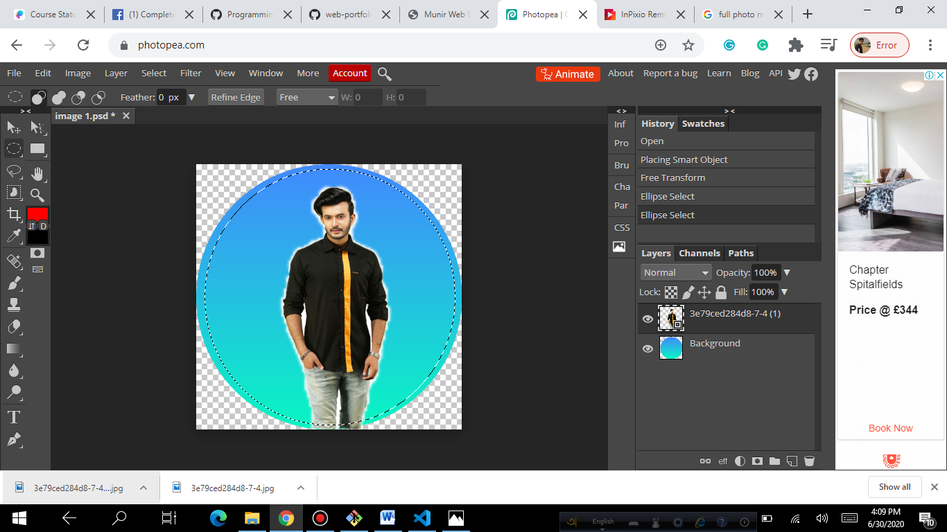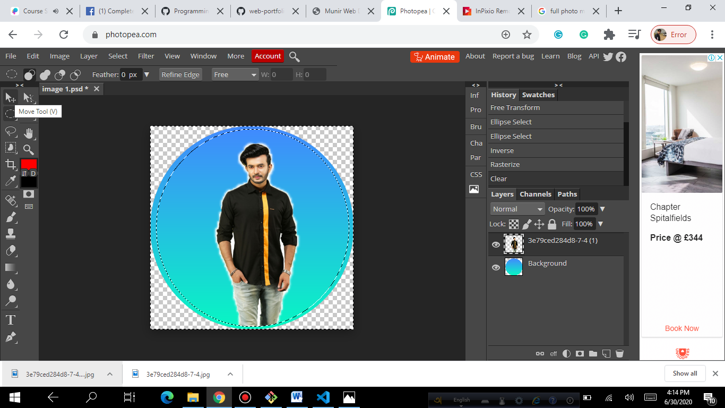

Now go file 🡪 export 🡪 PNG 🡪Save 🡪 Enter

**VIDEO 4.5:**

**Step 09:**

***Now our paragraph all tags (heading/ paragraph) will put under section tags to organize our website perfectly. (Here, I wrote paragraph shortly)***

<section>

        <h1>Welcome To</h1>

        <h1><span class="first-site">My First</span> Website</h1>

        <h3>World Class Web Developer</h3>

  <p>I am very much interested ……………… immediately. So, I take this</p>

</section>

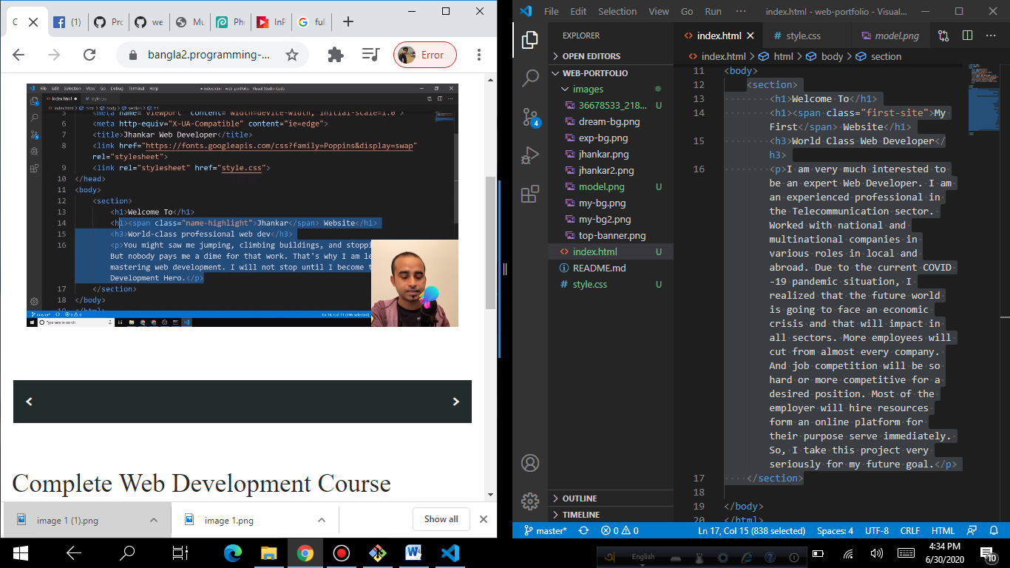

Note: Now if we just put inside section tags then we can’t prepare the Jhanker Mahbub bhai’s same website because there first half showing left side paragraph and right side photo.

And second half first just inverse plus down side have other style. So, if we want to make exact that type of website we will out our headings/ paragraph inside <div></div> tags.

We Use two div tags one for our headings / paragraphs and another for image.

<section>

        <div>

            <h1>Welcome To</h1>

            <h1><span class="first-site">My First</span> Website</h1>

            <h3>World Class Web Developer</h3>

            <p>I am very much interested to ……………….goal.</p>

        </div>

        <div>

            <img src="images/model.png" alt="">

        <div>

</section>

Now we use a class name for both div 🡪 <div class="half-width">

Because, we will use 50% for image and 50% for sentences.

**NOW in CSS**: we style our class (half-width) 🡪 witdth: 40%; 🡪float: left;

.half-width{

    width: 40%;

    float: left;

}

Now our website screen looks like below.

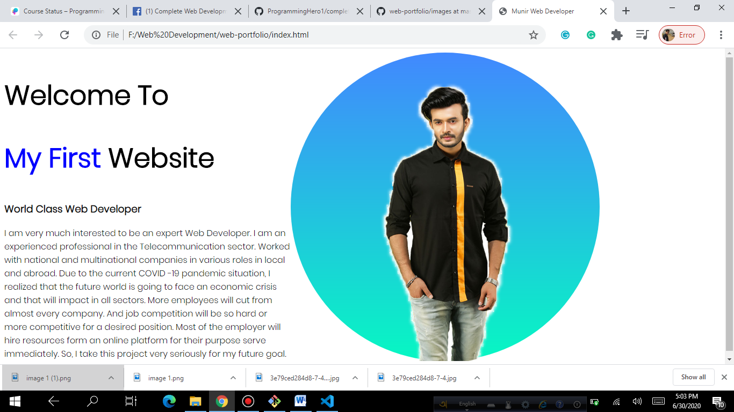

**Now we will apply more style:**

Now we will write command for image inside half-width. That all images inside half-width will be 100%. 🡪 .half-width img{ }

Now till this part we can push to Github. Then go View 🡪 terminal

🡪 git add .

* git commit –m”top part added” 🡪 (just given a name)
* git push 🡪 (all commands push done to Github)

**PS F:\Web Development\web-portfolio> git add .**

**PS F:\Web Development\web-portfolio> git commit -m"top part added"**

[master e634666] top part added

4 files changed, 43 insertions(+)

create mode 100644 images/36678533_2188567474705093_7370378619710865408_n.jpg

create mode 100644 images/model.png

create mode 100644 index.html

create mode 100644 style.css

**PS F:\Web Development\web-portfolio> git push**

Enumerating objects: 9, done.

Counting objects: 100% (9/9), done.

Delta compression using up to 4 threads

Compressing objects: 100% (7/7), done.

Writing objects: 100% (7/7), 345.20 KiB | 1.15 MiB/s, done.

Total 7 (delta 1), reused 0 (delta 0), pack-reused 0

remote: Resolving deltas: 100% (1/1), completed with 1 local object.

To https://github.com/MunirAlHossain/web-portfolio.git

65aae34..e634666 master -> master

**PS F:\Web Development\web-portfolio>**

PS F:\Web Development\web-portfolio>

fwd-i-search: _

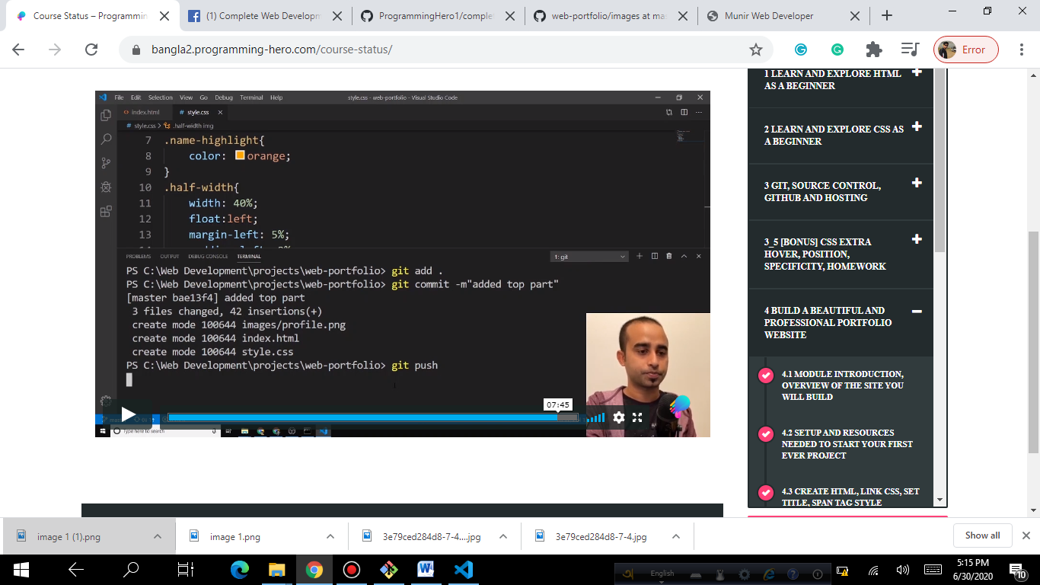

**VIDEO 4.6:**

**STEP 10:**

Now we will use background image/color for our 1st paragraph plus photo (top part of our website)

Then we use a class=”” into our 1st <section> tag.

**IN HTML:**

<section class="top-banner">

**In CSS:**

.top-banner{

    background-image: url("images/top-banner.png");

}

*After applied this formula we can’t see any changes in our website (I mean no background is visible) because when we applied float-left then our paragraph and photo came to side by side which was before up and down word. When it comes side by side then we don’t have any height in down.*

Now we will apply this formula 🡪 for all sections

section{

    height: 500px;

}

Now we can see background is showing twice/ more than that.

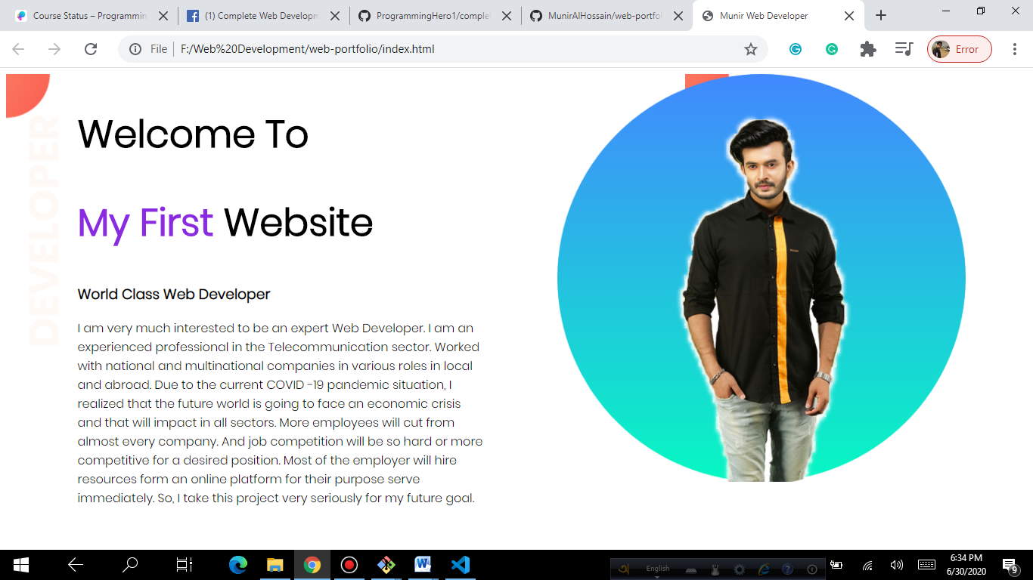

**To avoid this problem we will apply this Formula:**

.top-banner{

    background-image: url("images/top-banner.png");

    background-repeat: no-repeat;

}

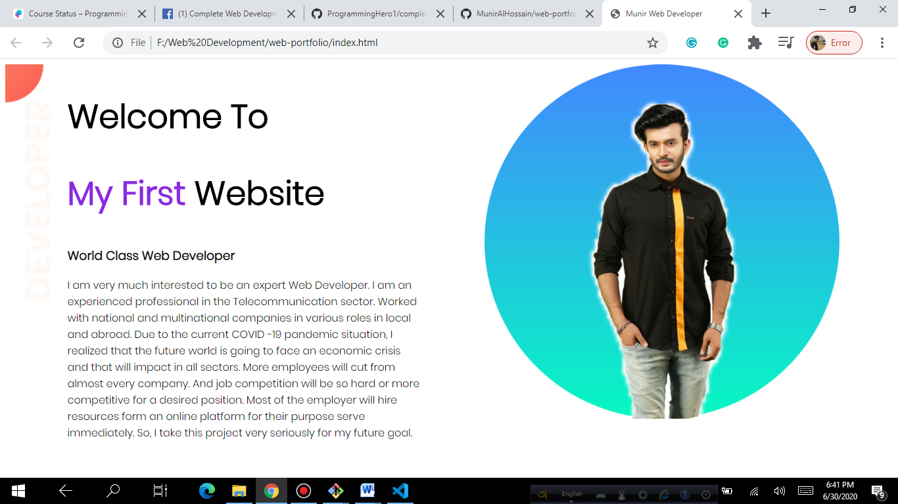

Now we can see background is not repeated.

Now we can see our left side background has slide gap which is actually browser set it by default. But we can remove it by using this formula in CSS file.

body{

    margin: 0px;

}

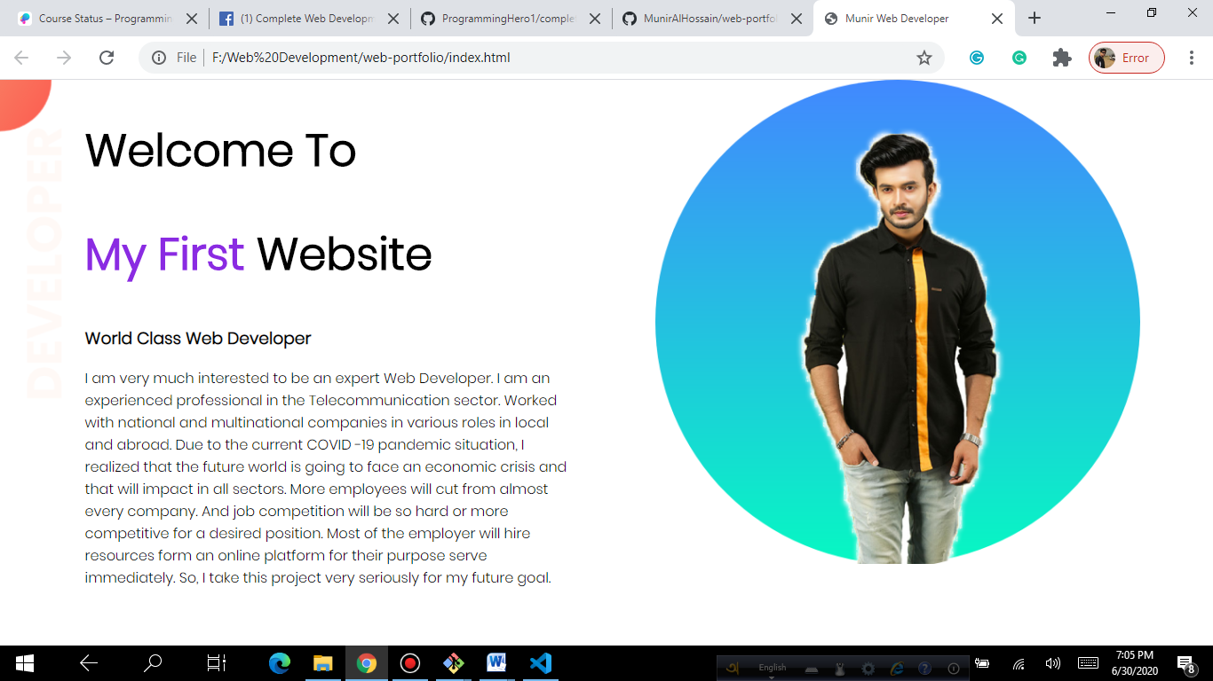

Now we can see there is no gap.

**VIDEO 07:**

**STEP: 11**

**Now we will use anchor tag and button tag.**

**After pargraph we will use this anchor tag <a></a>**

**<a href="https://www.programming-hero.com/">click me</a>**

**Here I used programing hero is my reference site.**

**And comment inside tags is 🡪 click me.**

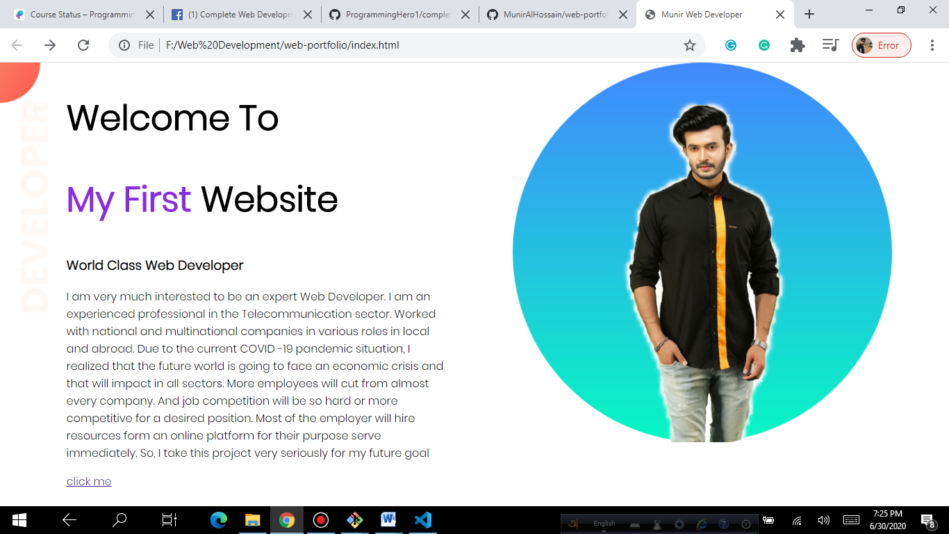

***When we click me then new link show in my website but we want it will open in a new tab. Then we will command this attribute inside out anchor tag.***

<a target="blank" href="https://www.programming-hero.com/">click me</a>

**Now we can see it open in a new tab.**

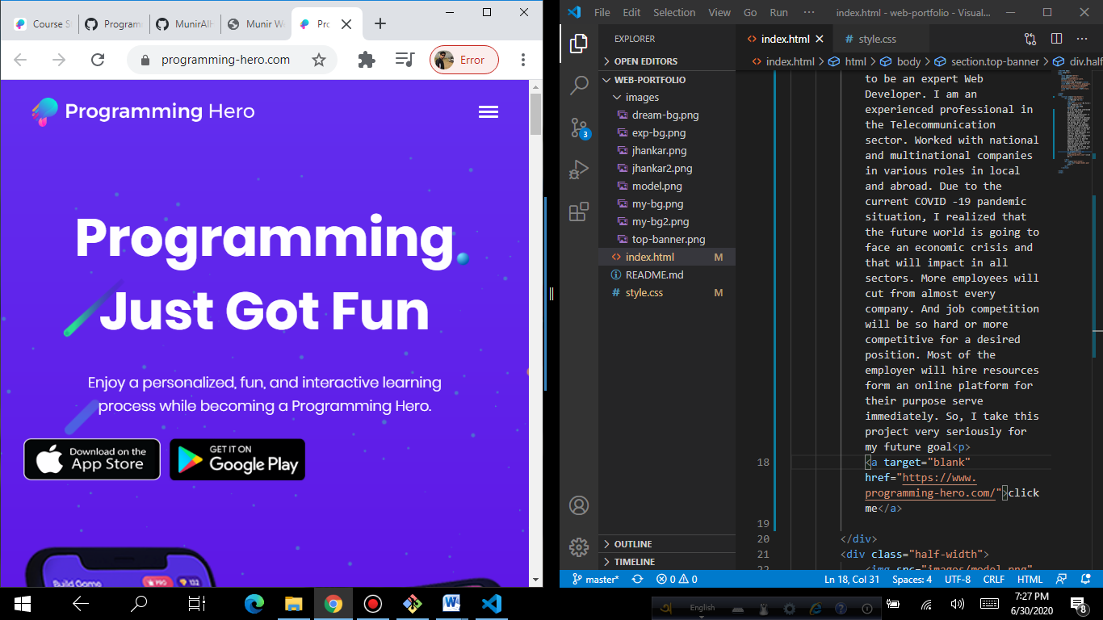

**Now we will give style to our click me button**

**Here we can see** [click me](https://www.programming-hero.com/) has under line. At first we will remove it. IN HTML we create a class which name we give class=“link-button” and text-direction: none in Css file.

**IN HTML:** class=”link-button”

<a class="link-button"target="blank" href="https://www.programming-hero.com/">click me</a>

**IN CSS:**

}

.link-button{

text-decoration: none;

}

**Now applied this Formula to give a full style to our click me button.**

.link-button{

    text-decoration: none;

    background-color: crimson;

    padding: 10px 20px;

    border-radius: 5px;

    color: white;

    font-weight: 700 ;

}

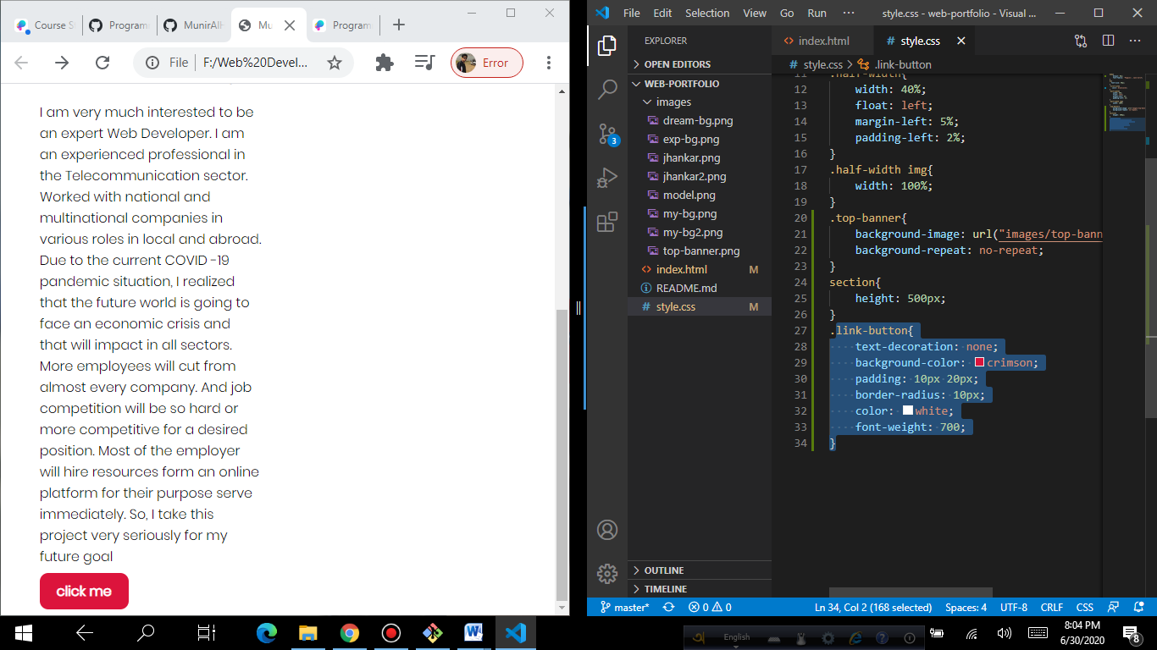

Also, we can do more style then we delete background-color And apply background-image: linear-gradient(45deg, blue, tomato);

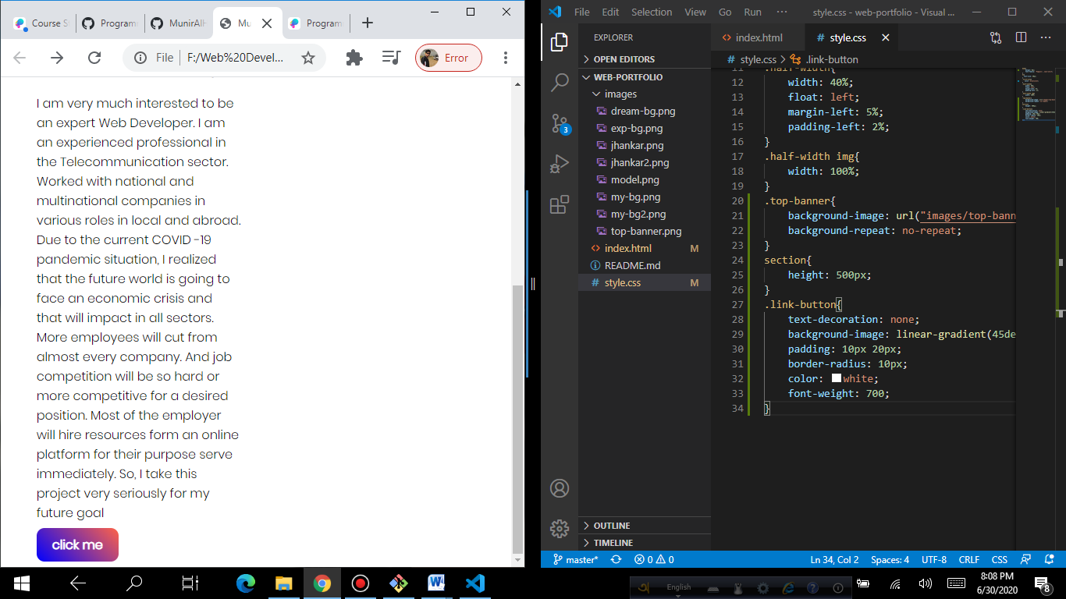

Now our first part is done.

**VIDEO 08:**

**Process:12**

**Now we will apply two div inside a new section.**

<section class="Dream Big">

        <div class="half-width">

        </div>

        <div class="half-width">

        <div>

</section>

**Here we no need to style CSS because we already applied.**

**Now we will add our 2nd image. To resize our image we just follow our first procedure.**

**Go🡪**

**1st open inpixio and remove your photo background**

**2nd open photopea 🡪 upload your background – then upload your photo and edit as per requirement.**

***After doing this apply img tag inside 1st div in second section tag.***

**FORMULA: in HTML file**

img src="images/hero.png" alt="">

**And in CSS do little work in section area to do a padding gap.**

section{

    height: 500px;

    padding-bottom: 150px;

}

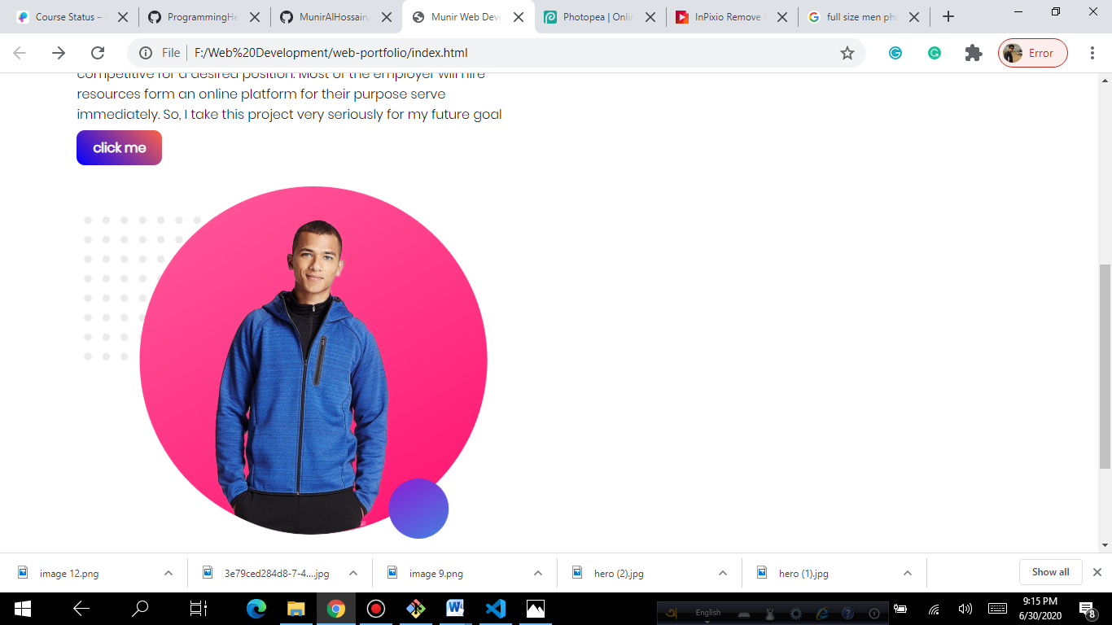

[24m](https://www.facebook.com/groups/completewebdevelopment/?multi_permalinks=913791389115725%2C913790689115795%2C913790415782489%2C913790045782526%2C913788735782657&notif_id=1593403483646506&notif_t=group_activity)

* [**Pro Rasel**](https://www.facebook.com/IT.ProRasel?comment_id=Y29tbWVudDo5MTM3NzQwMTkxMTc0NjJfOTEzNzg1OTU5MTE2MjY4)[https://static.xx.fbcdn.net/rsrc.php/v3/yi/r/oJUaDQAiBQe.png](https://www.facebook.com/groups/893000287861502/badge_member_list/?badge_type=ADMIN) 1) আপনি নতুন রিপো (repository) খুলে সেখানে আপনার নতুন ওয়েব সাইট হোস্ট করতে পারেন। মনে রাখবেন, একই repository তে মাত্র একটা ওয়েব সাইট হোস্ট করা যায়। তাই সেইম repository তে হোস্ট করতে চাইলে, সেটার কোড কেটে দিয়ে কিংবা আলাদা ফোল্ডারে রেখে। তারপর নতুন ওয়েব সাইট এর index.html হোস্ট করতে পারেন। তবে ভালো হয় আপনি নতুন একটি repository খুলে ওয়েব সাইট হোস্ট করেন।  
    
  2) আপনি বাড়তি class অথবা id ব্যবহার করতে পারবেন। যতোগুলো করেন, তাতে অসুবিধা হবে না। তবে মনে রাখবেন, id বা class গুলোর নাম অবশ্যই যেনো অর্থ পূর্ণ (meaningful) হয়। হাবিজাই, অথবা, abssdkf এই টাইপের হলে মার্কস কম পাওয়া চাঞ্জ বেশি।

[#ReSolved](https://www.facebook.com/hashtag/resolved?__eep__=6&source=feed_text&epa=HASHTAG)

push Error. what to do now

[[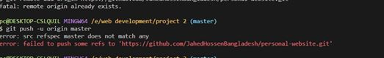](https://www.facebook.com/photo.php?fbid=3135156709877146&set=gm.913828765778654&type=3&eid=ARCsL8UwiN-3piGd8WkO7EbGlsEvWItkcRhuEZ8z3kGnduZTd5gA4Mpbc4EkjiPxJl-Hq1IljiLNWqQM&ifg=1)](https://www.facebook.com/photo.php?fbid=3135156709877146&set=gm.913828765778654&type=3&eid=ARCsL8UwiN-3piGd8WkO7EbGlsEvWItkcRhuEZ8z3kGnduZTd5gA4Mpbc4EkjiPxJl-Hq1IljiLNWqQM&ifg=1)

Top of Form

[2 comments](https://www.facebook.com/groups/completewebdevelopment/permalink/913828765778654/)

[**Like**](https://www.facebook.com/groups/completewebdevelopment/?multi_permalinks=913835279111336%2C913834232444774%2C913829752445222%2C913828765778654%2C913828139112050&notif_id=1593403483646506&notif_t=group_activity)

[**Comment**](https://www.facebook.com/groups/completewebdevelopment/?multi_permalinks=913835279111336%2C913834232444774%2C913829752445222%2C913828765778654%2C913828139112050&notif_id=1593403483646506&notif_t=group_activity)

**Comments**

* [Manik Roy](https://www.facebook.com/manikroy89?comment_id=Y29tbWVudDo5MTM4Mjg3NjU3Nzg2NTRfOTEzODI5MzcyNDQ1MjYw)

[**Manik Roy**](https://www.facebook.com/manikroy89?comment_id=Y29tbWVudDo5MTM4Mjg3NjU3Nzg2NTRfOTEzODI5MzcyNDQ1MjYw)[https://static.xx.fbcdn.net/rsrc.php/v3/yi/r/oJUaDQAiBQe.png](https://www.facebook.com/groups/893000287861502/badge_member_list/?badge_type=ADMIN) first => git remote rm origin  
second => git remote add remoteURL  
thired => git push -u origin master

[1](https://www.facebook.com/ufi/reaction/profile/browser/?ft_ent_identifier=ZmVlZGJhY2s6OTEzODI4NzY1Nzc4NjU0XzkxMzgyOTM3MjQ0NTI2MA%3D%3D&av=100052164670862)

Hide or report this

* + [Like](https://www.facebook.com/groups/completewebdevelopment/?multi_permalinks=913835279111336%2C913834232444774%2C913829752445222%2C913828765778654%2C913828139112050&notif_id=1593403483646506&notif_t=group_activity)
  + · [Reply](https://www.facebook.com/groups/completewebdevelopment/?multi_permalinks=913835279111336%2C913834232444774%2C913829752445222%2C913828765778654%2C913828139112050&notif_id=1593403483646506&notif_t=group_activity)
  + · [6h](https://www.facebook.com/groups/completewebdevelopment/permalink/913828765778654/?comment_id=913829372445260)

Bottom of Form

[#resolved](https://www.facebook.com/hashtag/resolved?__eep__=6&source=feed_text&epa=HASHTAG) live link এবং repository link এর পার্থক্য একটু বুঝিয়ে বলবেন !

আমি কুইজ এ repository link দিয়েছি :  
[https://github.com/jasimkasba/web-portfolio](https://github.com/jasimkasba/web-portfolio?fbclid=IwAR1aSfC9ln2w544NPe3LlsoT1o_G9s_0KQlq-x-fSusQRwTj64T6F1qk17s)

আমি কুইজ এ live link দিয়েছি ,  
— [https://jasimkasba.github.io/web-portfolio/](https://jasimkasba.github.io/web-portfolio/?fbclid=IwAR3ayHhc36tg_LsOCWOKXxo8eQMLBqmRlezBGwW5gu9pa4j5r9KXz65-xus)  
ঠিক আছে কি ?